# **Beach Seine Surveys - Hakai Institute Advanced Metadata Form**

**Please fill in the following information for your dataset and return it to** [data@hakai.org](mailto:data@hakai.org)

Further metadata will be gathered and quality checked by the Hakai technology team. Your responses will be used to produce a metadata record which will be available at [hecate.hakai.org/geonetwork](https://hecate.hakai.org/geonetwork/srv/eng/catalog.search#/home)

**Title:**

**Topic – Location – Date(s) if applicable). Example: Jellyfish Monitoring Study – Pruth Bay, Calvert Island – September 2016.**

|  |
| --- |
| **Beach Seine Surveys - BC Central Coast - 2014-2018** |

**Point of contact information:**

**Name – research institution - email**

|  |
| --- |
| **Ben Millard-Martin - Hakai Institute - ben.millardmartin@hakai.org**  **Margot Hessing-Lewis – Hakai Institute – margot@hakai.org** |

**How the data should be cited:**

Example: (Evans, W., A. Hare, and K. Pocock. (2017). High-resolution record of surface seawater CO2 content from December 2014 to April 2016 collected in Hyacinthe Bay, British Columbia, Canada. Version 1.0. Hakai Institute. Dataset. [access date].)

|  |
| --- |
| **Brescht, M., Millard-Martin, B., Monteith, Z., and Hessing-Lewis, M.** |

**Abstract:**

**Full description of what the dataset is.**

|  |
| --- |
| **S**We assessed fish biodiversity, abundance and length distributions across habitat gradients on the BC Central Coast from 2014-2018. Beach seines were used to sample fish communities at 71 sites between rivers Inlet and the McMullins Islands. 16 sites were sampled annually in mid-summer. 6 sites were sampled monthly or bimonthly from May-September and opportunistically between October and April. 49 sites were sampled in the summer months of 2014 and 2015.  This dataset consists of several CSV files that contain spatial and habitat data, species abundance, species length, and environmental data. All files are linked by common fields (e.g. site; date; replicate; species). |

**Data Type:**

**Format: TXT / SHP / CSV / XLSX / WORD / LAS / etc.**

|  |
| --- |
| **TXT, WORD, CSV** |

**If it is a geospatial dataset please state coordinate system used:**

|  |
| --- |
| **lat/long NAD 83** |

**Temporal Coverage:**

**When was the data collected? Example: July 21st 2016 to August 10th 2016.**

|  |
| --- |
| **2014 - 2018** |

**External links to include**

**Metadata records / applicable documents / google drive folders.**

|  |
| --- |
| **none** |

**Keywords**

**List as many keywords that describe your dataset – as many as possible. Example: Oceanography, CTD, conductivity, temperature, salinity, depth, Calvert Island, coast, ocean, water, sample, plankton, chlorophyll.**

|  |
| --- |
| **beach seine, nearshore ecology, nearshore fish, seagrass** |

**Data Accessibility**

**Specify if you would like your data to be downloadable (public) / available to Hakai researchers internally / archived with individual researcher (privately held).**

|  |
| --- |
| **Available to public.** |

**Record Thumbnail Image**

**If you have a square thumbnail image that well represents this dataset please provide it along with this metadata sheet. If you do not have an image available one will be produced for you.**

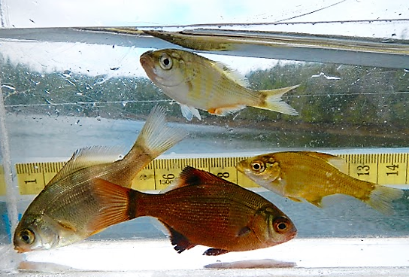

**Thank you for contributing to our metadata folder. Please submit to data@hakai.org**